Game Meat / Viande de gibier
Elk / Wapiti
Salami - Sliced

Ingredients: Domestic elk, Pork, Beef, Sea salt, Sugar (maple syrup), Cultured celery powder, Pepper, Garlic, Starter culture, Natural wood smoke.
Ingredients: Wapiti domestique, Porc, Bœuf, Sel de mer, Sucre (sirop d’erable), Poudre de céleri de culture, Poivre, Ail, Culture starter, Fumée de bois naturel.

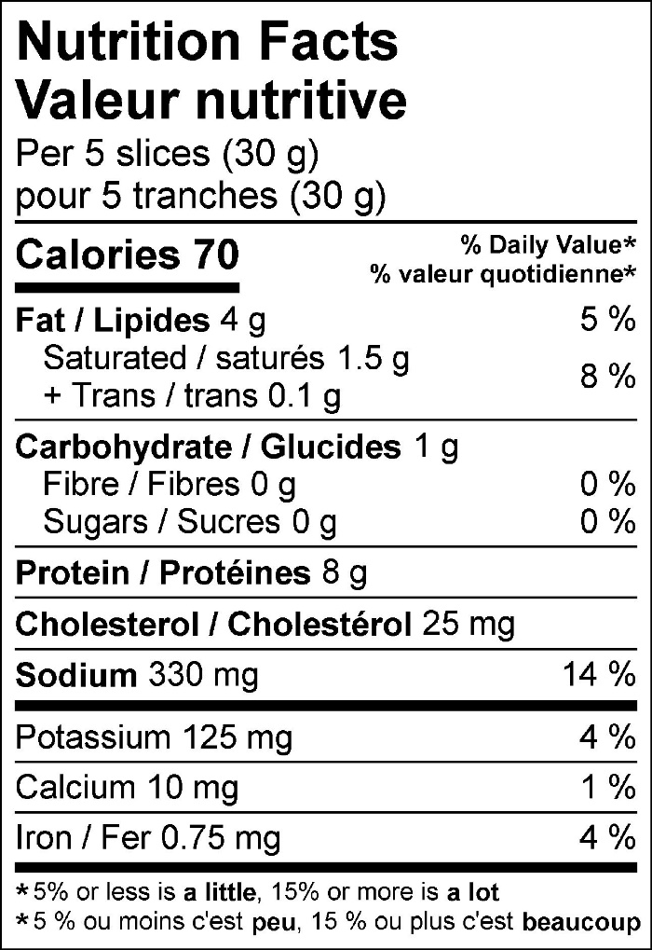

125 g pack


